Living Economy in Greece
Athens, 15 October 2014
Intervention by Tony Long, Director of WWF EPO at the conference organised by WWF Greece

I start my intervention with a quotation from the then International President of WWF, Chief Anayaoku, at a major conference in Brussels in 2007:
“Our way of living is not only threatening the health and diversity of our planet’s species, but has become a huge threat to human survival as well.
- Societies cannot continue to operate as if the planet was a business in liquidation.
- We cannot continue to turn our backs on pollution and call it someone else’s problem.
- We cannot continue to call income what in reality is resource depletion.
- We cannot claim economic success for development patterns that leave hundreds of millions of people marginalised and which stoke the fears of resentment and conflict.
We need to move beyond conventional economic accounting. We are calling for new ways to measure and record progress so that we can take the necessary corrective measures to set a more wise development path.”
These were prophetic words. It is interesting that they were made before the full impact of the financial crisis hit the USA and then Europe.
Seven years later, another WWF colleague writing on a similar subject published a book last month - In Pursuit of Prosperity. In 10 country and regional case studies from China, to Indian, to the Arctic, to Congo and Mexico onwards, David reveals just how far resource scarcity in rural areas is disrupting livelihoods and accelerating migration of tens of millions of inhabitants to urban areas.
"The question is not whether resource scarcity in other parts of the world will affect US prosperity and national security, but rather when and how. And, in equal measure, how will the US government and our economy respond to the attendant social unrest and economic disruption?"
It reminds you of the T-shirts being worn by some of the hundreds of climate change protestors marching through New York City a couple of weeks ago – with huge pandas printed on the front of the T-shirt the slogan below was – “Save the Humans.”
But I am not here to talk about the US level, or the global level, but rather Europe, and specifically the EU response. It would be wrong to think that nothing has happened in response to Chief Anayaku’s appeal and others like him.
- The EU adopted the Europe 2020 Strategy early 2010 calling for smart, sustainable and inclusive growth
- It subsequently created the EU Semester, the implementing tool for intervening in Member State macro-economic policies.
- ‘Resource efficient Europe’ is one of the flagship initiatives of the Europe 2020 Strategy.
- On this basis the Commission published the 2011 Roadmap to a Resource-Efficient Europe.
- In the 7th Environmental Action Programme, Member States and the European Parliament agreed that the EU should establish indicators and set targets for resource efficiency, and assess the appropriateness of a lead indicator and target in the European Semester. A 30% resource productivity target by 2030 has been suggested by the Commission.
- The EU 2020 Biodiversity Strategy endorsed by the Council in 2011 put forward a commitment for Member States to map and assess their ecosystems services by 2014 and ‘promote the integration of these values into accounting and reporting systems at EU and national levels by 2020’.
- In2011, the Regulation on European Environmental Economic Accounts was adopted: it requires Member States to regularly report on several environmental areas (‘modules’).
- The regulation allows for new modules to be introduced, such as a module on ecosystem services; the next opportunities for adding new modules are 2016 and 2019.
- In 2014 the Commission published a progress review, opening a public consultation to revise the Europe 2020 Strategy in 2014-2015.
- Also in 2014, barely a few weeks ago, the Commission published various proposals under the Circular Economy package. Introducing the package, Commissioner Potocnik repeated his now well-known theme. Resource costs make up a significant part of the cost structure of European business. EU manufacturing firms spend on average 40% of their costs on raw materials (going up), far more than labour costs (around 20%, going down) or energy costs. Improving resource efficiency – in other words, producing products and services with fewer resources and reducing EU imports of resources – is set to become more important than labour productivity as a driver of competitive advantage.
These are just some examples of what might be called a greening economy process getting underway at European level. It is not a complete list. And there are some other initiatives – like a sustainability scorecard - that have fared less well running into data and methodological problems.
I think it is right at this point to ask three questions:
- Why is it happening now?
- How much political commitment lies behind this transition? Is it indeed a transition?
- Is it enough?
Evidence suggests that economic growth in Europe tends to be structurally going down (whatever policy and government) and is now historically low. For example in France, based on official INSEE statistics the economist Grandjean calculated the average economic growth per decade in the last fifty years is moving structurally downwards :

Figure XX. Annual evolution of French GDP per capita and decade average in the period 1960-2009
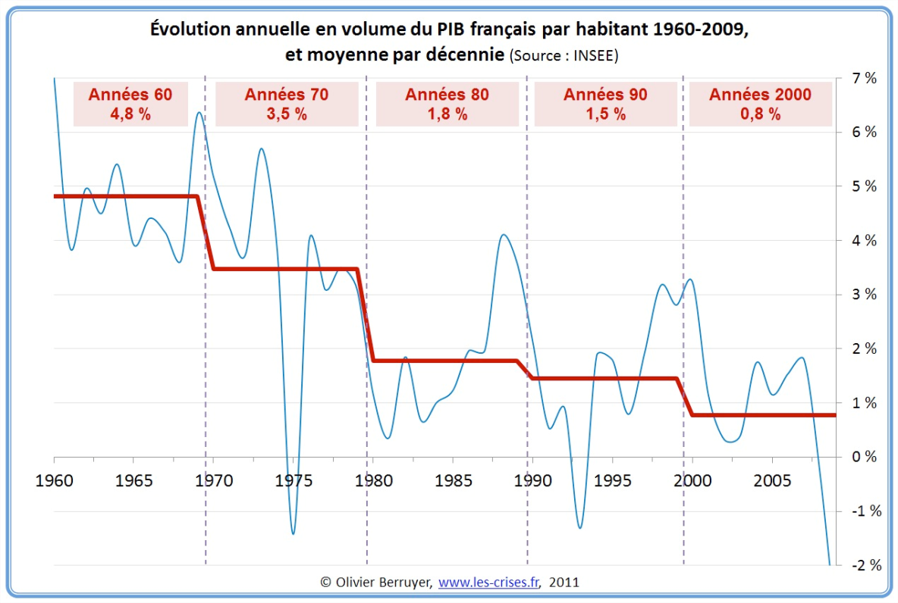
Source: http://alaingrandjean.fr/2012/05/25/a-la-recherche-de-la-croissance-perdue/
At the EU level, the President of the European Central Bank Mr Draghi, declared recently that growth in Europe is “weak, fragile and uneven”, and EU growth prospects from the World Bank or the IMF don’t look more appealing.
So in answer to the question why now, perhaps we are witnessing a response to the overall sluggishnesss of European economies and a new way of beginning to measure and possibly manage them. Or possibly that politicians are now in the unenviable position of having only a bag of growth indicators to sell to their increasingly skeptical and knowledgeable electorates who want and need to be presented with other indicators of well-being and progress.
On the second question, how much political commitment exists, there the judgement has to be more cautious. Jobs, growth, competitiveness is on everyone’s lips in Brussels these days. Sustainable development or green growth or even green economy is not.
The green groups in Brussels raised the alarm last month when we complained that for the first time in two decades we were losing a dedicated Environment Commission position. Just as worringly, none of the new Commissioner mandates contained a reference to sustainability – it was everyone and no-one’s responsibility answered Mr Juncker. Let us put it this way, the agenda that I just presented to you was not anywhere near the top of the list of the new Commission proposals. More will leak out tomorrow and next week to know if that problem is being fixed in response to the Parliament’s pressure.
Then to the third question is it enough – is the policy response urgent enough? Well, I think I will answer that it in a different way. There are two huge tests of commitment coming at a global level in the next 12-14 months. The first will be the sustainable development goals incorporating and replacing the Millenium Development Goals. These will be decided next autumn in the United Nations. How far these goals usher in a genuine new global commitment to living and sharing equitably and universally on one planet will be a real test of commitment. So too will be the climate commitments entered into in the COP 21 in Paris just 2 months later.
And before both of these, European Heads of State and Government will meet at the end of next week to decide their own journey to 2030 on their own climate and energy ambitions and targets. Will they adopt 40% CO2 cuts over 1990 levels, 30% share of renewables and 30% energy efficiency gains by 2030? And will they be binding targets?
Is the policy response urgent enough?
We are soon set to find out.
Thank you

European Commission (2010), Europe 2020 - A strategy for smart, sustainable and inclusive growth, COM(2010) 2020
European Commission (2010), Europe 2020 - A strategy for smart, sustainable and inclusive growth, COM(2010) 2020
European Commission (2013), Roadmap to a Resource Efficient Europe, COM(2011) 571 final
Decision No 1386/2013/EU of 20 November 2013 on a General Union Environment Action Programme to 2020 ‘Living well, within the limits of our planet’
The European Parliament also issued the resolution of 24 May 2012 A resource-efficient Europe (2011/2068(INI) asking for targets and indicators
European Commission (2014), Towards a circular economy: A zero waste programme for Europe, COM(2014) 398final
European Commission (2011), Our life insurance, our natural capital: an EU biodiversity strategy to 2020, COM(2011) 244 final
Environment Council of 21 June 2011, Luxembourg
European Commission (2011), Our life insurance, our natural capital: an EU biodiversity strategy to 2020, COM(2011) 244 final: Target 2 Action 5
Regulation No 691/2011 of 6 July 2011 on European environmental economic accounts
European Commission (2014), Taking stock of the Europe 2020 strategy for smart, sustainable and inclusive growth, COM(2014) 130 final
Europe INNOVA (2012), Guide to resource efficiency in manufacturing: Experiences from improving resource efficiency in manufacturing companies
Le Monde, 9 August 2014, Pour la BCE les conditions sont réunies pour une baisse durable de l’euro
See the World Bank’s growth estimates and forecasts, http://www.worldbank.org/en/publication/global-economic-prospects/data

